DAT601

Assessment 1

Report

Isaac Smith

# Part 0. introduction to data modelling

The purpose of data modelling as the name suggests is to map the structure of data for the purposes of implementing an effective database design. To effectively design a database, we need to measure our working against five principles to ensure that the proposed design is solid and effective.

The first is **Data Integrity**. Data integrity essentially means that all data stored within the database remains accurate, complete and isn’t susceptible to corruption or alteration from unintended sources.

The second is **Data Consistency**. Data consistency refers to data being the same no matter where it is accessed or viewed from, and that one record of data is the same no matter where it is.

The third is **Data Security**. And that means that data is properly protected from being accessed by unauthorised sources.

The fourth is **Accessibility**. That data is always available for the right source when it is needed.

And the fifth is **Scalability**. The databases’ ability to grow with the data it collects and there for fulfilling any future requirements from the database, whether its business or technical.

# Part 1. Conceptual Modelling using Chen EERD

Conceptual Modelling is considered the initial designs of an information system, since it is the first design it is supposed to be loosely representative of how a system is structured rather than how it is supposed to operate. The main purpose is to identify the entities in the system, their relationships between them and the attributes each entity has so all parties involved have a surface level understanding of the proposed system design.

The advantage to this level of design means we don’t need to worry about technical or physical constraints of the system or how the data is stored and only worry about identifying the structure of the proposed system.

**Entities:**

* Standard Entity: is a representation of a system component, physical machine, an employee or a concept. Is shown as a standard rectangle.
* Weak Entity: is an entity which relies on another entity to exist, for instance in my diagram I have Data as a weak entity, because the data wouldn’t exist unless the FRED collects it. Is shown as a double outlined rectangle.
* Associative Entity: is an entity that is used in a Many – to – Many relationship and represents an extra table, in my diagram I used a associative entity for the maintenance record between location and FRED to record the record of jobs the FRED does.

**Attributes:**

* Simple Attributes: represent a single value of an entity, (e.g Name, Email, Position). Is shown as a solid outlined oval
* Composite Attributes: represent an attribute which is the sum of other attributes. Is shown as an attribute with attributes attached to it.
* Derived Attributes: represent an attribute gained from another attribute. and it’s shown as an oval with a dashed outline.
* Multivalued Attributes: represent an attribute that can have multiple values, and it’s represented by an oval that has a double outline.

**Relationships:**

* Relationships: are a representation of how entities relate to one another, typically use verbs to describe how the relationships work. Are represented by diamonds.

**Relationship Optionality:**

* Mandatory: denotes that the connected entity or each record of that entity must be involved in the relationship connect. Is represented by a solid line.
* Optional denotes that the connected entity or each record of the entity can but doesn’t have to be involved in the relationship. Is represented by a dashed line.

**Cardinality:**

* One-to-one: This represents that one record of each entity is involved in the relationship. Is represented by the number 1 on each relationship connection.
* One-to-many: this represents that one record of one entity is applied to many or all records of another entity. This is represented by the number ‘1’ on one connection and the capital letter ‘N’ on the other.
* Many-to-one: This represents that many records from one entity are involved in a relation with opposing entity. It is represented the reverse of the previous cardinality (N – 1)
* The final cardinality is Many-to-many: This represents that 1 record can form a relationship with many records of the opposing entity and the same is true.

**Keys:**

* Primary Key: Represent the primary identifier attribute for an entity. It Is shown by the name of the attribute being underlined.

**Data integrity** is practiced throughout the diagram by practicing proper primary key implementation through the entities, the relationships between the entities and the cardinality of those relationships. And that weak entities are always attached to normal ones.  
This ensures that data correctly flows between the entities in the system.

**Data Consistency** is practiced by properly identifying relationships and attributes ensuring that data is properly handled across all entities.

**Data Security,** while it is hard to practice data security through the conceptual design phase, proper identification of important or sensitive attributes will ensure that further design will incorporate proper considerations.

**Accessibility** is demonstrated by ensuring that the flow of data through cardinality and relationships is properly mapped.

**Scalability** is demonstrated by proper use of aggregation and generalization, which suggests that future iterations of the design can easily be implemented.

# Part 2. Conceptual Chen EERD

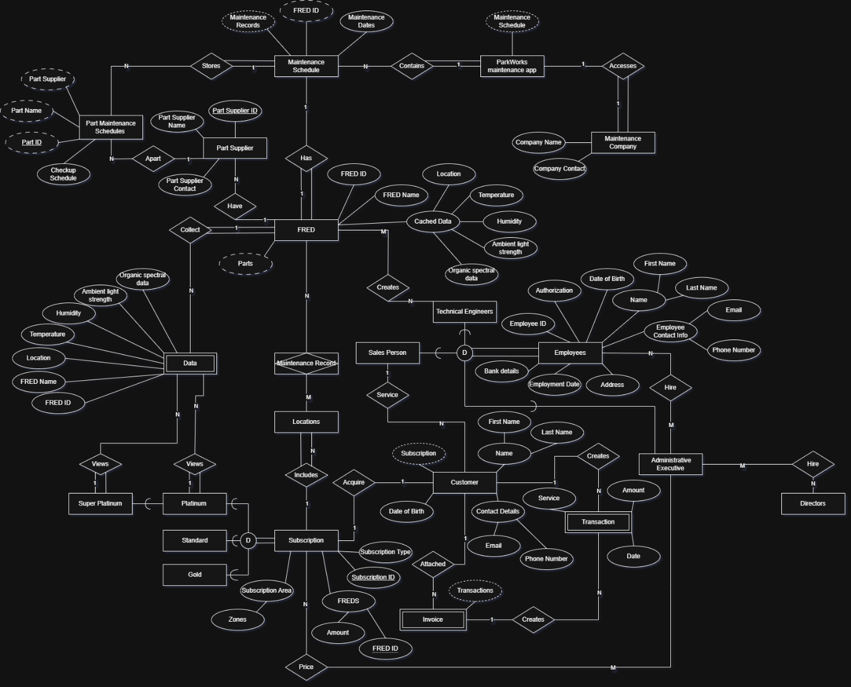

# Part 3. Data Dictionary

**Conceptual Model Documentation**

**Table 1: Document Entities**

|  |  |  |  |
| --- | --- | --- | --- |
| **Entity Name** | **Description** | **Aliases** | **Occurrence** |
| Maintenance Schedule | Entity used to track FRED Maintenance and store part maintenance. | Maintenance Schedule | One maintenance schedule Per FRED |
| Part Maintenance Schedule | Entity that tracks the maintenance of individual parts. | Part Maintenance Schedule | Represents one maintenance schedule |
| Part Supplier | Entity that represents part suppliers | Part Supplier | Represents one part supplier |
| ParkWorks maintenance app | Entity that represents the maintenance app | Maintenance app | Represents the one application |
| Maintenance Company | Entity represents the third-party maintenance company | Maintenance Company | Represents the one application |
| FRED | Entity represents one FRED | FRED | Is one instance of a FRED |
| Maintenance Record | Associative entity represents the services rendered by a FRED at the location they are in | Maintenance Record | Is once instance of a Maintenance record for one FRED |
| Locations | Entity Representing the locations as a part of a subscription | Location | Is one instance of a location |
| Data | Entity that represents the data collected and stored by the FREDs | Data | Is all data collected and stored |
| Subscription | Represents a contract between ParkWorks and a Customer | Subscription | Represents one Subscription instance |
| Standard | Represents a standard subscription and inherits its attributes from the Subscription entity | Standard subscription | Represents a type of subscription |
| Gold | Represents a gold subscription and inherits its attributes from the Subscription entity | Gold Subscription | Represents a type of subscription |
| Platinum | Represents a platinum subscription and inherits its attributes from the Subscription entity | Platinum Subscription | Represents a type of subscription |
| Super-Platinum | Represents a super platinum subscription and inherits its attributes from the Subscription entity | Super-Platinum Subscription | Represents a type of subscription |
| Employees | This entity represents one employee | Employee | A single instance of an employee |
| Technical Engineer | As an entity that inherits from the Employee entity and creates FREDS | Employee | A single Technical Engineer instance of employee |
| Salesperson | Is an entity that inherits from the Employee entity and sells subscriptions to customers | Employee | A single Salesperson instance of employee |
| Administrative Executive | Entity representing an administrative employee | Employee | A single instance representing one administrative executive. |
| Directors | Entity responsible for instating Amin Execs | Employee | A single instance of a director |
| Transaction | Entity represents transactions made by customers | Transaction | Represents a single Transaction |
| Invoice | Entity representing a collection of transactions | Invoice | Represents a single invoice |

**Table 2: Document Relationships/Specializations- Generalizations**

|  |  |  |  |  |  |  |
| --- | --- | --- | --- | --- | --- | --- |
| **Entity Name** | **Cardinality** | **Participation** | **Relationship** | **Participation** | **Cardinality** | **Entity Name** |
| FRED | 1 | Mandatory | Has | Mandatory | 1 | Maintenance Schedule |
| Maintenance Schedule | 1 | Total Participation | Stores | Mandatory | N | Part Maintenance Schedules |
| Part Maintenance Schedules | N | Mandatory | Apart | Mandatory | 1 | Part Supplier |
| FRED | 1 | Mandatory | Have | Mandatory | N | Part Supplier |
| Maintenance Company | 1 | Total Participation | Accesses | Mandatory | 1 | ParkWorks maintenance app |
| ParkWorks maintenance app | 1 | Total Participation | Contains | Mandatory | N | Maintenance Schedule |
| FRED | 1 | Total Participation | Collects | Mandatory | N | Data |
| Locations | M | Mandatory | Maintenance Record | Mandatory | N | FRED |
| Subscription | 1 | Mandatory | Includes | Total Participation | N | Locations |
| Subscription(platinum) | 1 | Mandatory | Views | Mandatory | N | Data |
| Subscription(super-platinum) | 1 | Mandatory | Views | Mandatory | N | Data |
| Directors | N | Mandatory | Hire | Mandatory | M | Administrative Executive |
| Administrative Executive | M | Mandatory | Hire | Mandatory | N | Employees |
| Administrative Executive | M | Mandatory | Price | Mandatory | N | Subscription |
| Technical Engineers | N | Mandatory | Creates | Mandatory | M | FRED |
| Salesperson | 1 | Mandatory | Service | Mandatory | N | Customer |
| Customer | 1 | Mandatory | Acquire | Mandatory | 1 | Subscription |
| Customer | 1 | Mandatory | Creates | Mandatory | N | Transactions |
| Transactions | N | Mandatory | Creates | Mandatory | 1 | Invoice |
| Invoice | N | Mandatory | Attached | Mandatory | 1 | Customer |

**Table 3: Document Attributes**

| **Entity Name** | **Attributes** | **Description** | **Domain** | **Aliases** | **Composite** | **Derived** | **Nulls** | **Key?** | **Default Value** |
| --- | --- | --- | --- | --- | --- | --- | --- | --- | --- |
|  | Maintenance Records | An individual record from the maintenance Schedule | VARCHAR(255) | Maintenance Record | No | Yes | No | No | Unknown |
| **Maintenance Schedule** | FRED ID | The FRED id for attached to that FREDs maintenance schedule | INT | FRED ID | No | Yes | No | Yes | 0 |
|  | Maintenance Date | The dates of upcoming maintenance and completed maintenance | DateTime | Maintenance Date | No | No | No | No | 1753-01-01 |
|  | Part Supplier | The supplier of the part | VARCHAR(255) | Part Supplier | No | Yes | No | No | Unknown |
|  | Part Name | The name of the part | VARCHAR(255) | Part Name | No | Yes | No | No | Unknown |
|  | Part ID | The ID for the part | INT | Part ID | No | Yes | No | Yes | 0 |
| **Part Maintenance Schedule** | Checkup Dates | The dates the part has been and needs to be maintained | DateTime | Checkup Dates | No | No | No | No | 1753-01-01 |
|  | Schedule ID | The id for a single Schedule | INT | Schedule ID | No | No | No | Yes | 0 |
|  | Part Supplier ID | The ID for the part supplier | INT | Part Supplier ID | No | No | No | Yes | 0 |
|  | Part Supplier Name | The name of the part supplier | VARCHAR(255) | Part Supplier Name | No | No | No | No | Unknown |
| **Part Supplier** | Part Supplier Contact | The contact information for the part supplier | INT | Part Supplier Contact | No | No | Yes | No | Unknown |
| **FRED** | FRED ID | The individual ID for a FRED | INT | FRED ID | No | No | No | Yes | 0 |
|  | FRED Name | The name of the FRED | VARCHAR(255) | FRED Name | No | No | Yes | No | Unknown |
|  | Cached Data | The data captured by the FRED that gets cached | INT | Cached Data | No | No | Yes | No | 0 |
| **ParkWorks Maintenance App** | Maintenance Schedule | The stored schedules for all FREDS | JSON | ParkWorks Maintenance App | No | No | No | No | 0 |
| **Maintenance Company** | Company Name | The name of the company | VARCHAR(255) | Company Name | No | No | No | No | Unknown |
|  | Company ID | The ID for the maintenance companies | INT | Company ID | No | No | No | Yes | 0 |
|  | Company Contact | The contact information for the maintenance company | INT | Company Contact | No | No | No | No | 0 |
| **Data** | Organic spectral data | Data collected by a FRED | INT | Organic spectral data | No | No | No | No | 0 |
|  | Ambient light strength | Data collected by a FRED | INT | Ambient light strength | No | No | No | No | 0 |
|  | Humidity | Data collected by a FRED | INT | Humidity | No | No | No | No | 0 |
|  | Temperature | Data collected by a FRED | INT | Temperature | No | No | No | No | 0 |
|  | Location | Location the data was collected from | INT | Location | No | No | No | No | 0 |
|  | FRED Name | Name of the FRED | VARCHAR(255) | FRED Name | No | Yes | No | No | 0 |
|  | FRED ID | ID of the FRED | INT | FRED ID | No | Yes | No | Yes | 0 |
| **Locations** | Location ID | ID of the location | INT | Location ID | No | No | No | Yes | 0 |
|  | Location Name | Name of the location | VARCHAR(255) | Location Name | No | No | No | No | Unknown |
|  | Location Address | Addresses of the location | VARCAHR(255) | Location Address | No | No | No | No | Unknown |
| **Subscription** | Subscription Type | The type of subscription | VARCHAR(255) | The type of subscription | No | No | No | No | Unknown |
|  | Subscription ID | The ID of the subscription | INT | Subscription ID | No | No | No | Yes | 0 |
|  | Subscription Area | Contains the zones the subscription is based on | VARCHAR(255) | Subscription Area | No | No | No | No | Unknown |
|  | FREDs | The FRED/FREDS assigned to the subscription | INT | FREDs | No | Yes | No | No | 0 |
|  | FRED ID | The ID of the assigned FRED | INT | FRED ID | No | Yes | No | Yes | 0 |
|  | FRED Name | The name of the FRED | VARCHAR(255) | FRED Name | No | Yes | No | No | Unknown |
|  | FRED AMOUNT | The Amount of FREDs attached to the subscription | INT | FRED AMOUNT | No | No | No | No | 0 |
| **Customer** | Customer ID | The ID of the customer | INT | CustomerID | No | No | No | Yes | 0 |
|  | Name | The whole name of the customer | VARCHAR(255) | Name | No | No | No | No | Unknown |
|  | First Name | The first name of the customer | VARCHAR(255) | First Name | No | No | No | No | Unknown |
|  | Last Name | The last name of the customer | VARCHAR(255) | Last Name | No | No | No | No | Unknown |
|  | Date of Birth | The date of birth of the customer | Date | Date of Birth | No | No | No | No | 0 |
|  | Subscription | The subscription attached to a customer | Boolean | Subscription | No | No | No | No | False |
|  | Contact Details | The contact information for the customer | VARCHAR(255) | Contact Details | No | No | No | No | Unknown |
|  | Email | The email address of the customer | VARCHAR(255) | Email | No | No | No | No | Unknown |
|  | Phone Number | The phone number of the customer | INT | Phone Number | No | No | No | No | 0 |
| **Transaction** | Amount | The amount the transaction cost | INT | Amount | No | No | No | No | 0 |
|  | Date | The date and time the transaction occured | DateTime | Date | No | No | No | No | 0 |
|  | Service | The services rendered for the transaction | VARCHAR(255) | Service | No | No | No | No | Unknown |
|  | Transaction ID | The ID of the transaction | INT | Transaction ID | No | No | No | Yes | 0 |
| **Invoice** | Transaction ID | The IDs of the transactions contained within the invoice | INT | Transaction ID | No | Yes | No | Yes | 0 |
|  | Invoice ID | The ID of the Invoice | INT | Invoice ID | No | No | No | Yes | 0 |
| **Directors** |  |  |  |  |  |  |  |  |  |
| **Employees**  **(generalized entity)** | Employee ID | The ID of the Employee | INT | Employee ID | No | No | No | Yes | 0 |
|  | Employment Date | The date the employee was hired | DateTime | Employment Date | No | No | No | No | Null |
|  | Bank Details | The Bank Information of the employee | INT | Bank Details | No | No | No | No | 0 |
|  | Authorization | The level of authorization for employee | Boolean | Authorization | No | No | No | No | False |
|  | Date of Birth | The date of birth for the employee | DateTime | Date of Birth | No | No | No | No | Null |
|  | Name | The full name of the employee | VARCHAR(255) | Name | No | No | No | No | John Smith |
|  | First Name | The first name of the employee | VARCHAR(255) | First Name | No | No | No | No | John |
|  | Last Name | The last name of the employee | VARCHAR(255) | Last Name | No | No | No | No | Smith |
|  | Employee Contact Details | The contact Information for the Employee | VARCHAR(255) | Employee Contact Details | No | No | No | No | Unknown |
|  | Email | The Email address for the employee | VARCHAR(255) | Email | No | No | No | No | Unknown |
|  | Phone Number | The phone number of the employee | INT | Phone Number | No | No | No | No | 0 |
|  | Address | The address of the employee | VARCHAR(255) | Address | No | No | No | No | Unknown |

# Part 4. Business Rules

## Employees:

* Only a Director can choose an Executive Administrator
* An Executive Administrator hires Technical Engineers and Sales Staff
* Only an Executive Administrators are allowed to enter the details for a contract
* Only Technical Engineers can build FREDs
* One Salesperson can oversee more than on customer

## Customer:

* Customers can have more than one Transaction
* Invoices can contain more than one Transaction
* Customers can only have one subscription at a time

## Subscription:

* Subscriptions can only be one type at one time, which dictates the area/s covered and FRED/s assigned to the subscription.
* If the subscription is platinum or higher the customer can view the data collected by the FREDs

## FREDs:

* Depending on the subscription type, more than one FRED can be assigned to one or more areas.
* FREDs track the services done at each location
* FREDs collect data as they work at each location
* One FRED is made of Many parts
* One FRED has one Maintenance Schedule
* One FRED has one Maintenance Record

## Maintenance:

* One maintenance schedule must track multiple part maintenance schedules
* One part maintenance schedule must track the part supplier for the part
* The maintenance schedule must be store by the ParkWorks app